Name: _____________________________ Teacher: _____________________ Period: _______

English II Pre-AP
Resource Packet

2020 - 2021
Table of Contents
Item | Page
Feedback Key | 3-5
Parts of Speech | 6
Sentence Structure | 7
Sentence Beginnings | 8
Who or Whom and Essential and Non-Essential Phrases | 9
Active and Passive Voice | 10-11
Literary Vocab | 12-15
Embedding and Incorporating Quotations | 16-17
DIDLS chart for Literary and Rhetorical Analysis | 18
Tone Chart | 19
Rhetorical Triangle & “They Say, I Say” | 20
Writing Thematic Statements | 21
Thesis Help Words | 22
Poetry Notes | 23-26
TPCASTT | 27
Body Paragraph Structure | 28
Developing a Body Paragraph | 29
Multiple Points of Development | 30
Persuasive writing for the STAAR Exam | 31-32
Example STAAR Essay | 33
STAAR Essay Rubric and Scoring Guide | 34
MLA Formatting | 35
MLA Sample Page | 36
Synthesis Essay Notes | 37-38
Guideline for Sticky Notes | 39

Feedback Key

Use the numbers and letters to understand your teacher’s feedback. For example, if your teacher writes 9A, you have made a spelling error.
- Introduction
  - Ineffective Hook.
  - Great Hook.
  - Ineffective/Inappropriate use of examples in your introduction.
  - You need to develop your introduction further by developing the concept or exigence you wish to discuss more completely. (i.e. Your introduction is too jumpy and/or I don’t know why you are talking about what you are.)
  - Your introduction is particularly strong and illuminating, and ultimately effective.
- Thesis
  - Your thesis is weak, oversimplified, ineffective, or doesn’t Answer the Prompt.
  - Your thesis does not contain a clear universal/unifying idea (i.e., You may need an “in order to...” statement) OR the answer to the prompt is wrong or incomplete.
  - The quote in your thesis is ineffective and/or incorrect.
  - Your thesis does not illuminate what the essay (and body paragraphs) will be about.
  - Your thesis is effective; it is both clear and intelligently addresses all aspects of the prompt.
  - Your thesis is particularly strong.
- Body Paragraphs – Topic Sentence
  - You do not have a clear topic sentence and must assert a clear idea at the beginning of the paragraph .
  - You need to add a “why”/ “in order to...” statement to give your topic sentence purpose OR your “why” is incorrect.
  - Effective topic sentence.
- Body Paragraphs – Evidence
  - More examples will help prove this point. Examples are too few to convince the reader of the validity of the argument.
  - Your examples may be ill-chosen or incorrect.
  - Your example is too abstract, hypothetical, or not detailed enough OR you need to insert actual textual evidence from source material.
  - Your textual evidence is too long OR you provide too much summary.
  - Impressive, interesting and well explained example used to effectively demonstrate your point.
  - You need a concession / refutation OR you need to explain yours more fully.
- Body Paragraphs – Commentary and Analysis
  - How?—So?—This is important because...?—You need to explain how your example(s) prove your point.
  - Explain the evidence’s relationship to your thesis OR topic sentence.
  - Your analysis may be off topic/tangential, incorrect or fallacious.
  - Your analysis is too vague and/or more analysis is needed; develop your ideas; try using the word “because” more.
  - Your analysis is repetitive. You repeat yourself too much. It is the same idea over and over again.
  - You should lead into your next body paragraph by connecting it in some way with the prior.
  - Insightful, well-developed analysis!
- Conclusion
  - Your conclusion is weak or disorganized.
  - Your conclusion is underdeveloped; you need more.
  - Your conclusion should extend the argument or ideas presented in your thesis.
  - Your conclusion needs to situate your argument in a larger context OR add a “So What.”
  - Add a “Call to Action,” OR make sure that you directly address the reader in your CTA.
- Quote Integration
  - Effective use of quotes; they are embedded nicely into your own syntax.
  - Citation or reference is unclear.
  - Citation error
  - Punctuation error
  - This is not a good quote choice to prove your argument.
  - You should steer away from starting a sentence with a quote and/or using it as its own sentence. Use context to introduce your quote.
  - You must provide more context in order for your quote to be effective.
  - Limit the amount of context / summary here.
- Cohesion and Organization
  - You need to use transitional language within the paragraph in order to relate the ideas and/or examples to each other.
  - Logical and smooth transition.
  - Your train of thought is unclear.
  - Your line of reasoning is logical and ideas progress logically.
  - You are presenting a new idea and, therefore, need a new paragraph.
- Grammar and Conventions
  - Spelling error
  - Capitalization error
  - Word or letter omission
  - Avoid slang and informal language.
  - This sentence has been written in passive voice by the author. Rewrite it in active voice.
  - Comma or semi-colon error
  - Verb Agreement error
  - Run-on sentence
  - Sentence fragment
  - Other punctuation error
  - Unclear pronoun reference: I don’t know who he, she, or it is.
  - Word usage error (This word is not used correctly, or the connotation is not quite what you intend)
- Syntax
  - Effective, varied, and purposeful syntax
  - Sentence is awkward OR does not make sense.
  - This sentence is too long or wordy.
  - Vary sentence structure or beginnings because the ideas are sounding repetitive.
- Voice
  - Sophisticated, confident, and knowledgeable voice.
  - Language is too simplistic (ie. instead of “really mad” say “furious” or “irate”).
  - Language is too flowery or word usage is too high compared to rest of essay.
  - Do not use evaluative or judgmental language. That’s lame.
  - Use more qualifying words like “some” or “might” or “may.” Only a Sith deals in absolutes.
  - Be more sensitive when discussing this topic. You do not want to offend your reader.
- MLA
  - Missing Part of Heading
  - Date written incorrectly (Correct: 4 January 2020)
  - Page Number/Name at top of essay is missing OR incorrect
  - Text alignment or margin error
  - Spacing error (Check that you do not have an extra space between paragraphs)
  - Works Cited is missing OR a source is missing/unclear

**Modified from an original document produced by Gretchen Polnac and Brendan Kenny

Parts of Speech

Part of Speech | Definition | Examples
Interjection | an abrupt remark, made especially as an aside or interruption
 | word used to describe an action, state, or occurrence | Run, Swim, Fly
Adverb | A word that modifies a verb
Noun |  | George Orwell, the park, language, diversity
 | A word that renames a noun | He, it, them
Adjective | A word that ________________ a noun or pronoun | Chilly, Orange, Stinky
Conjunction | A word that links word, phrases, and clauses
 | A word that expresses a relationship to another word or element | Of, To, In  (The diver swam ___ the shark)

Sentence Structure

Sentence Type | Structure | Example
Simple
Compound
Complex
Compound-Complex

Subordinating Conjunctions:

Sentence Beginnings

Type | Description | Example Sentence
Prepositional
Phrase
Infinitive
Phrase
Appositive
Phrase
Participial
Phrase
Past Participial
Phrase
Adjective
Clause
Adverb
Clause
Absolute
Phrase

Who or Whom?

Essential and Non-Essential Phrases

Using Active and Passive Voice

Active Voice
Active voice is used to show that the subject is performing or causing the action.

Example:
LeBron threw the basketball before the buzzer.
LeBron shot the basketball from the free throw line.
Ex. _____________________________________________

Passive Voice
Passive voice is used when the subject is the recipient of the action.

Example:
The ball was thrown by LeBron before the buzzer.
The basket was shot by LeBron.
Ex. _______________________________________________

Why does it matter?
STRONG WRITING USES _____________________________________
- Active voice is more ____________________ and _____________________.
- Passive voice is usually ______________________.

Active voice is like watching LeBron play.
Passive voice is like watching gum stuck on the bleachers in the stands.

MOST OF THE TIME, YOU WANT TO USE ACTIVE VOICE!

When would you WANT to use passive voice?
- When intentionally trying to hide the subject of the sentence
  - For example, a politician might say, “Poor decisions were made.”
- Hiding the subject helps hide the blame or indicate that the subject is unknown.
  - My iPod was stolen from the locker room.
- When intentionally trying to minimize the guilt of the subject
  - For example an corporate executive might say, “Oil was spilled in the gulf.”
- When passive voice better emphasizes the main idea of the message.
  - such as “Children were harmed.”

How to find Passive Voice
The passive voice requires "to be" and the past participle (a "double verb" and will always consist of a form of the verb usually the "en/ed/t" form) of another verb.
Example:
Active: John baked the bread.
Passive: The bread was baked by John. (Was is a form of the verb “be”.)

Note the forms of "to be" in the examples of the verb "to kick" in various forms of the passive voice:

is kicked----------------had been kicked
was kicked-------------is going to be kicked
is being kicked---------will be kicked
has been kicked-------can be kicked
was being kicked------should be kicked

Let’s Practice:
Identify the following sentences ACTIVE or PASSIVE with an A or P.

- The chocolate cake was made by Louise.
- The package was advertised by the travel agent.
- My brother broke the chain on my bike.
- I hemmed the prom dress.
- The pencil on the floor was broken by him.

Rewrite the sentences above in the opposite voice.
- __________________________________________________________________________________________________________________________________________________________________________

- __________________________________________________________________________________________________________________________________________________________________________

- __________________________________________________________________________________________________________________________________________________________________________

- __________________________________________________________________________________________________________________________________________________________________________

- __________________________________________________________________________________________________________________________________________________________________________

Literary Vocab

Abstraction: An abstraction uses a broad term that paints different pictures in each person's mind, such as: "She's beautiful," instead of telling us what the artist sees, leaving the appearance ambiguous.

Ad hominem: Fallacy (“to the man”) that target’s a person’s characteristics instead of their argument.

Ad populum: Fallacy (to the crowd”) that argues that the widespread occurrence of something makes the idea true or right.

Allegory: A story illustrating an idea or a moral principle in which objects take on symbolic meanings.

Alliteration: A repetition of the initial sounds of several words in a group.

Allusion: A reference in one literary work to a character or theme found in another literary work, history, or reference.

Analogy: A comparison between two things, typically on the basis of their structure and for the purpose of explanation or clarification.

Anaphora: A rhetorical device that consists of repeating a sequence of words at the beginnings of neighboring clauses, thereby lending them emphasis. Ex: “I have a dream…” repeated at the beginning of several sentences in MLK’s famous speech

Anecdote: A very short tale told by a character in a literary work. In rhetoric, this is a personal story used as evidence, and is generally seen as weak support.

Anthropomorphism: A literary device that can be defined as a technique in which a writer ascribes human traits, ambitions, emotions or entire behavior to animals, non-human beings, natural phenomena or objects. While Anthropomorphism gives human characteristics to non-humans, Personification gives human characteristics to animals or objects to create imagery.

Apostrophe: A figure of speech wherein the speaker speaks directly to something nonhuman. In these lines from John Donne's poem "The Sun Rising" the poet scolds the sun for interrupting his nighttime activities:
Busy old fool, unruly sun, / Why dost thou thus, / Through windows, and through curtains call on us?

Archetype: In literature, an archetype is a typical character, an action or a situation that seems to represent such universal patterns of human nature.

Aside: A device in which a character in a drama makes a short speech which is heard by the audience but not by other characters in the play.

Assonance: The repetition of vowel sounds in a literary work, especially in a poem. Edgar Allen Poe's "The Bells" contains numerous examples. Consider these:
“Hear the mellow wedding bells-/ and/ From the molten-golden notes,”
The repetition of the short e and long o sounds denotes a heavier, more serious bell than the bell encountered in the first stanza where the assonance included the i sound in examples such as tinkle, sprinkle, and twinkle.

Catharsis: The process of releasing, and thereby providing relief from, strong or repressed emotions. Though the catharsis is purifying, it is not redemptive. A catharsis usually takes place through a cleansing process or with cleansing metaphors (ie. Water or fire).

Characterization: The method a writer uses to reveal the personality of a character in a literary work: Methods may include (1) by what the character says about himself or herself; (2) by what others reveal about the character; and (3) by the character's own actions.

Climax: The decisive moment in a drama, the climax is the turning point of the play to which the rising action leads.

Colloquial: Informal language characterized by a conversation tone or slang.

Conflict: In the plot of a drama, conflict occurs when the protagonist is opposed by some person or force in the play.

Connotation and Denotation: The denotation of a word is its dictionary definition. The connotation of a word is its emotional content.

Consonance: The repetition of consonant sounds with differing vowel sounds in words near each other in a line or lines of poetry. Unlike alliteration, these sounds can be anywhere in the word. Consider the following example from Theodore Roethke's "Night Journey:"
We rush into a rain/ That rattles double glass.

Diction: An author's choice of words. Since words have specific meanings, and since one's choice of words can affect feelings, a writer's choice of words can have great impact in a literary work. During WWII, there were several government documents that referred to Japanese-Americans as “non-aliens” instead of citizens.

Double Entendre: A literary device that can be defined as a phrase or a figure of speech that might have multiple senses, interpretations or two different meanings or that could be understood in two different ways, usually with a risqué implication.

Epistrophe
The repetition of words or phrases at the end of a phrase. In the Gettysburg Address, Lincoln speaks of a “government of the people, by the people, for the people…”

Ethos: A persuasive appeal to credibility or believability. For example, trusting the word of a director when talking about film interpretations.

Euphemism: A mild word of phrase which substitutes for another which would be undesirable because it is too direct, unpleasant, or offensive.

Exposition: In drama, the presentation of essential information regarding what has occurred prior to the beginning of the play.

Extended Metaphor: A metaphor in a work of prose or poetry that continues for more than one instance, usually a creating a continuing theme through the work. For example, The Ghost Map uses an extended metaphor to compare London’s lowest classes to ghosts as they are invisible, mute and unable to act socially or politically with the other classes.

Figurative Language: In literature, a way of saying one thing and meaning something else. While, figurative language provides a writer with the opportunity to write imaginatively, it also tests the imagination of the reader, forcing the reader to go below the surface of a literary work into deep, hidden meanings.

Figure of Speech: An example of figurative language that states something that is not literally true in order to create an effect. Similes, metaphors and personification are figures of speech which are based on comparisons.

Flashback: A reference to an event which took place prior to the beginning of a story or play.

Foil: A character in a play who sets off the main character or other characters by comparison. Much can be learned about each by comparing and contrasting the actions of the two.

Foreshadowing: In drama, a method used to build suspense by providing hints of what is to come

Hyperbole: A figure of speech in which an overstatement or exaggeration occurs

Imagery: A word or group of words in a literary work which appeal to one or more of the senses: sight (visual), taste (gustatory), touch (tactile), hearing (auditory), and smell (olfactory).

Inference: A judgement based on reasoning rather than on direct or explicit statement. A conclusion based on facts or circumstances.

Irony: In situational irony, the result of an action is the reverse of what the actor expected. In dramatic irony, the audience knows something that the characters in the drama do not. In verbal irony, the contrast is between the literal meaning of what is said and what is meant. Sarcasm is a form of verbal irony.

Juxtaposition (in verb form, to juxtapose): Two things being seen or placed close together with contrasting effect.

Litotes: A figure of speech which employs an understatement by using double negatives or, in other words, positive statement is expressed by negating its opposite expressions. For example, saying “She is not a beauty queen,” meaning “She is ugly”. Litotes, therefore, is an intentional use of understatement that renders an ironical effect.

Logos: A persuasive appeal to logic, usually a statistic or quantitative fact.

Memoir: A story about the author’s past written through his or her perspective. Unlike an autobiography, it usually is centered on one aspect of a person’s life such as their upbringing or years lived in a foreign country, etc.

Metaphor: A figure of speech wherein a comparison is made between two unlike quantities without the use of the words "like" or "as."

Mood: The atmosphere or feeling created by a literary work, partly by a description of the objects or by the style of the descriptions.

Non Sequitur: Fallacy (“it does not follow”) when the speaker makes an unconnected jump from one idea to the next without relating the two subjects.

Onomatopoeia: A literary device wherein the sound of a word echoes the sound it represents.

Oxymoron: A combination of contradictory terms, such as used by Romeo in Act 1, scene 1 of Shakespeare's "Romeo and Juliet:" Why then, O brawling love! O loving hate! /O heavy lightness, serious vanity;

Pathos: A persuasive appeal to emotion. An argument that relies too heavily on emotional appeal is an emotional fallacy.

Paradox: A situation or a statement that seems to contradict itself, but on closer inspection, does not. Ex. “alone in a crowd”
Parallel Structure: A repetition of sentences using the same structure. This line from Abraham Lincoln's Gettysburg Address: The world will little not nor long remember what we say here, / but it can never forget what they did here.

Parody: A literary work that imitates the style of another literary work. A parody can be simply amusing or it can be mocking in tone, such as a poem which exaggerates the use of alliteration in order to show the ridiculous effect of overuse of alliteration.

Personification: A figure of speech in which something nonhuman is given human characteristics. For example, "Justice is blind."

Plot: The structure of a story. The sequence in which the author arranges events in a story. The structure of a five-act play often includes the rising action, the climax, the falling action, and the resolution. The plot may have a protagonist who is opposed by antagonist, creating what is called, conflict.

Point of View: A piece of literature contains a speaker who is speaking either in the first person, telling things from his or her own perspective, or in the third person, telling things from the perspective of an onlooker. If the speaker knows everything including the actions, motives, and thoughts of all the characters, the speaker is referred to as omniscient (all-knowing). If the speaker is unable to know what is in any character's mind but his or her own, this is called limited.

Protagonist: The hero or central character of a literary work. In accomplishing his or her objective, the protagonist is hindered by some opposing force.

Pun: A play on words wherein a word is used to convey two meanings at the same time. The line below, spoken by Mercutio in Shakespeare's "Romeo and Juliet," is an example of a pun. Mercutio has just been stabbed, knows he is dying and says: “Ask for me tomorrow and you shall find me a grave man.”

Satire: A piece of literature designed to ridicule the subject of the work. While satire can be funny, its aim is not to amuse, but to arouse contempt that leads to change. (See parody)

Setting: The time and place in which a story unfolds. This may also include the cultural and societal circumstances that effect the characters, plot, and language in the story.

Simile: A figure of speech which takes the form of a comparison between two unlike quantities and uses the words "like" or "as" in the comparison.

Soliloquy: In drama, a moment when a character is alone and speaks his or her thoughts aloud.

Stream of Consciousness: A method of narration that describes in words the flow of thoughts in the minds of the characters. Stream of consciousness is often marked by erratic punctuation and a harried feel.

Style: The writer’s characteristic manner of employing language. Many things enter into the style of a work: the author's use of figurative language, diction, sound effects and other literary devices. Think of an author’s particular work as a “mood” but their style as the author’s “personality.”

Symbolism: A device in literature where an object represents an idea.
Synesthesia: One sensory experience described in terms of another sensory experience. Emily Dickinson, in "I Heard a Fly Buzz-When I Died," uses a color to describe a sound, the buzz of a fly: with blue, uncertain stumbling buzz

Syntax: The arrangement of words and the order of grammatical elements in a sentence.

Theme: Unlike plot which deals with the action of a work, theme concerns itself with a work's message or contains the general idea of a work.

Tone: Tone expresses the author's attitude toward his or her subject.

Tragedy: According to A. C. Bradley, a tragedy is a type of drama which is pre-eminently the story of one person, the hero. The story depicts the trouble part of the hero's life in which a total reversal of fortune comes upon a person who formerly stood in high degree, apparently secure, sometimes even happy.

Understatement: A statement which lessens or minimizes the importance of what is meant.

EMBEDDING / INCORPORATING QUOTATIONS

ALL QUOTES must be introduced in an essay. Quotations cannot just “appear” in your paper as if they were plopped down from heaven. Readers must be properly prepared for all quotes.

In MLA formatting it is correct to place the citation at the end of the sentence OR directly after the quote. Both are correct.

DO NOT USE Stand alone quotes.

- A true embedded quote in an essay is the most impressive and demonstrates a more sophisticated strategy. Begin a sentence with your words, then embed a quote into the sentence and finish with your words.
a)
b)

- Notice the lack of punctuation before the quote and the lack of capitalization at the beginning of the quote.
- Treat the quote as if it is another phrase you are adding to your sentence; punctuate and capitalize accordingly. Often you will not need either as in the above examples.
- If you have to change the form of a word to make it fit grammatically in a sentence, then place brackets around the change [ ]. Do not leave the original word in the sentence.
- Remember YOU begin the sentence then start the quote where you need to. No ellipsis (...) needed if you chop off words at the beginning or end of a quote. You have permission to start quoting anywhere.
- However, after you have started your quote, you must use an ellipsis to indicate missing words or phrases in the middle of the quote.
- If all the quotes that appear are from one source and the reader knows which source, it is not necessary to repeat the author’s name.

- The following are examples of incorporating a quote into a sentence that a student has already begun.

- How to quote dialogue
  - When you are only quoting the spoken words, there is no need to add further punctuation.

  - When you are quoting dialogue inside a longer quote, use an apostrophe to denote spoken words.

- Multiple quotes in the same sentence in 1984
  - If the quotes are on the same page, put the citation at the end of the sentence.

  - If the quotes stretch from one page to another, use a dash.

  - If the quotes are not on the same page, put the citation directly after the quote.

- Punctuation: Note the location of the commas in the below sentences.

  - Incorrect: Winston is “thirty-nine,” (1) and he suffers from “coughing fit[s]” (32).
DIDLS for Literary and Rhetorical Analysis
DIDLS AREA | Areas to Examine | Question to Ask: Look for the WHY and link to author TONE
DICTION: | Examine the words that the author uses. Define the denotation of words that are crucial to the argument (even if you think that you know the word).  List the words and attempt to group or label the words based on their connotations. | - What are the important words of the piece?  - Why does the author choose certain kinds of words?  - What kinds of words can be grouped together?  - What words create contrasts?  - What words could be subbed into the writing instead of the key words and how would that change the meaning?  - What are the abstract words? What are the concrete words?
IMAGERY: | Examine the images that the author creates- remember there is more than just visual imagery.  Think about what mood is established through imagery and try to name it. | - Does any sense/reference dominate?  - How do the images impact the reader/listener?  - Is the image so detailed that you could draw it, or is it more abstract?  - What details in the image seem important?  - What does the image focus on or what does it leave out?
DETAILS: | Examine the following:  Title and its significance- think about it before you read and then after.  The Central Claim: locate the main claim being made by the author.  Key Evidence: locate key evidence from the piece that seems crucial to the overall meaning.  Examples/Allusions | - Does the meaning of the title change or grow after reading?  - What does the author want the reader to think, feel and understand?  - What sentences seem crucial to getting the audience to do, think or feel what the author wants?  - How do examples/allusions help the reader understand the author's claim?
LANGUAGE: | Examine the figurative language that the author uses such as metaphors, similes, puns, hyperbole, understatement, personification, symbolism, apostrophe, metonymy, etc.  Note the kinds of verbs and adjectives used by the author especially if the claim has to do with how an author feels about the subject. | - What figures of speech are used?  - What about the figure of speech helps the author meet his/her purpose?  - What about the subjects used in the figure of speech help with the purpose of the writing?  - What do the verbs and adjectives describe?
STRUCTURE/ SYNTAX | Look at the overall structure of the piece and the author’s craft. Note the transition words and how they help structure the writing.  Look at the sentence structures and how they are constructed. Examine the sentence type (interrogative, imperative, declarative, periodic (important info at the end), or cumulative sentence (important info at the start), simple or complex sentences.  Note the use of parallelism, juxtaposition, fragments, run-ons, short and long sentences.  Note the repetition of words, phrases and ideas  Note the punctuation choices.  Note whether the voice is active or passive. | - How would you describe the way the piece opens and closes (in regards to sent. structure)?  - What are the author's transitions within the piece and how would you describe them from ____ to ___ ?  - How do the sentences begin and end? Does anything repeat?  - How does the sentence length vary?  - Are there phrases that repeat the same pattern?  - Are there sentences that look grammatically incorrect?  - What kind of punctuation is used and when? Why does the author choose one over another?  - What words, phrases and ideas are repeated? Do they change or stay consistent in meaning?

TONE CHART
POSITIVE | NEGATIVE
Positive  awe--solemn wonder  compassionate--kind, humane, sympathetic  comic--amusing, funny  ecstatic--joyful, rapturous  earnest--intense, a sincere state of mind  erudite--learned, polished, scholarly  fanciful--using the imagination  impassioned--fiery, ardent  jovial--happy  lyrical-emotional; full of images; song-like; poetic  optimistic--hopeful, cheerful  quizzical--odd, eccentric, amusing  reverent--treating a subject with honor and respect  reflective--illustrating innermost thoughts and emotions  righteous--acting in a just, upright manner  sincere--without deceit or pretense; genuine  sanguine--optimistic, cheerful  whimsical--odd, strange, fantastic; fun  OTHER/NEUTRAL | Anger  accusatory--charging of wrongdoing  belligerent--warlike, ready to fight or quarrel  bitter--exhibiting strong animosity as a result of pain or grief  choleric--hot-tempered, easily angered  incendiary/incensed--extremely angry  indignant--marked by anger; aroused by injustice  sulking--resentful, petulant  Contempt  arrogant--full of pride, haughty  callous--unfeeling, insensitive to feelings of others  condescending--patronizing, disdainful, superior  critical--finding fault  contemptuous--showing or feeling that something is worthless or lacks respect  disapproving--dislike, deplore, criticize  disdainful--scornful  haughty--proud and vain to the point of arrogance  self-righteous--regarding oneself as being morally superior to others; smug  Ridicule/Sarcasm  caustic--intense use of sarcasm; stinging, biting  cynical--questions the basic sincerity and goodness of people  derisive--ridiculing, mocking  disparaging--belittling, discrediting  judgmental--authoritative and often having critical opinions  mocking--treating with contempt or ridicule  patronizing--air of condescension  ridiculing--slightly contemptuous banter; making fun of  sarcastic--sneering, caustic  sardonic--scornfully and bitterly sarcastic  satiric--ridiculing to show weakness in order to make a point, teach  Sadness  distressed- painful, miserable  gloomy-darkness, sadness, rejection,morose  pensive- reflective, often in a melancholy way  pessimistic- seeing the worst side of things; no hope  ribald-offensive in speech or gesture  solemn-deeply earnest, tending toward sad reflection  tragic-disastrous, fatalistic  apathetic- indifferent due to lack of energy or concern
Other
absurd--so unreasonable as to be ridiculous
frustrated--disappointed, defeated
hyperbolic--purposely exaggerated
imploring--begging, earnestly asking
jaded--tired, worn out; dulled or satiated
malicious--purposely hurtful
obsequious--polite and obedient in order to gain something
Neutral
didactic--author attempts to educate or instruct the reader
contemplative--thoughtful
conventional--lacking spontaneity, originality, and individuality
forthright--directly frank without hesitation
incredulous--showing doubt or disbelief
informative--giving information, instructive
intimate--very familiar
matter-of-fact- accepting of conditions; not fanciful or emotional
modest--shy or reserved
objective--an unbiased view; able to leave personal judgments aside
philosophical--reflective, rational, given to thought
resigned--quiet, docile, unresisting, subservient
unassuming—not forward, modest
Rhetorical Triangle
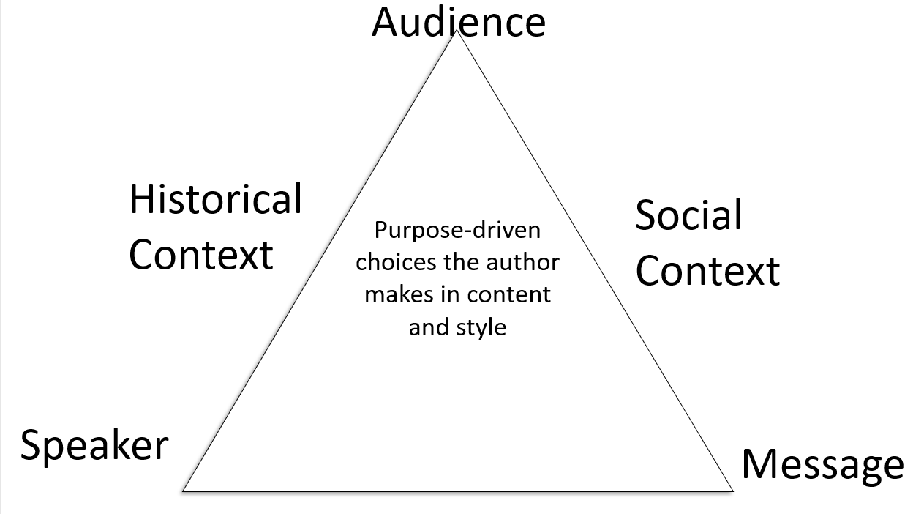
They Say/I Say: Three Ways to Respond
Disagree – And Explain Why | Agree – But with a Difference | Agree and Disagree Simultaneously
You need to do more than simply assert that you disagree with a particular view; you also have to offer persuasive reasons why you disagree. | As you are agreeing, it is important to bring something new and fresh to the table. Whatever mode of agreement you choose, the important thing is to open up some difference between your position and the one you’re agreeing with rather than simply parroting what it says. | This move in academic writing produces a reader-friendly response that can be tipped more toward agreement or disagreement.
X is wrong because he/she overlooks…  X’s claim that…rests upon the questionable assumption that…  Recent research contradicts X’s views in that…  By focusing on…, X overlooks the deeper problem of… | X is surely right that… because recent studies have proven that…  X is correct in that …a point that needs emphasizing, since so many people believe that…  If group X is right, then we need to reassess the popular assumption that… | Although X is correct up to a point, his final conclusion remains faulty because…  Although much of what X says is faulty, his final conclusion is sound because…  X is right that…, but she seems on more dubious ground when she claims that…
Graff, Gerald, and Cathy Birkenstein. “They Say/I Say” The Moves that Matter in Academic Writing. New York: W.W. Norton & Company, 2006.
Writing Thematic Statements
“Theme is the central message of a literary work. It is not the same as a subject, which can be expressed in a word or two: courage, survival, war, pride, etc. The theme is the idea the author wishes to convey about that subject. It is expressed as a sentence or general statement about life or human nature. A literary work can have more than one theme, and most themes are not directly stated but are implied. The reader must think about all the elements of the work and use them to make inferences, or reasonable guesses, as to which themes seem to be implied.” (from Laying the Foundation series of books published by AP Strategies in Dallas)
For example, if love is a topic/subject of two novels, a major theme in one of the novels could be “Love, if taken to extremes, can be negative rather than positive,” while in the other novel, the theme might be “Love can conquer even the greatest evil.” Notice that the topic/subject is the same, but the messages about that topic/subject are different in different works.
Consider this:
- A theme is a meaning of a work. (Yes, there can be more than one “meaning.”) Can the meaning of a work be love? hate? greed? No—that makes no sense! Those are just topics, not themes. The theme is the statement an author is making about a topic.

Stating the theme of a work of literature
- Begin by using several abstract words to state the principal ideas of the work (topics that the piece is really about). Abstract words describe concepts or ideas that exist only in our minds like alienation, prejudice, ambition, freedom, love, loyalty, passion, etc.
- Combine those abstract ideas with comments that reflect the author’s observations about human nature, the human condition, or human motivation. In other words, what is the author saying about the abstract idea? Is he/she, for example, saying something about the qualities of people and/or commenting on society?

Avoiding the common mistakes in writing a thematic statement
- A theme is NOT a moral, a directive, or an order. A moral/directive/order tells us how to behave or what to do. A theme observes, weighs, and considers actions and ideas, but it avoids judging what people should or should not do; therefore, words like “should” and “ought” are not appropriate in a thematic statement. Also not appropriate is an order/directive such as “Be nice to elderly people” or “Love like there’s no tomorrow.”

- Themes are NOT trite sayings (clichés, maxims, or aphorisms) such as “Actions speak louder than words,” “Love hurts,” or “Absence makes the heart grow fonder.”

- Themes do NOT refer to the specific names or events of a particular literary piece. A theme does not summarize a work, but it does reflect what happens in the work. A theme drops character names and uses more general terms like “parents,” “leaders,” “society,” or “young people” in a general observation about the human experience.

- Themes avoid absolute terms such as “all,” “none,” “everything,” or “always” because they indicate sloppy thinking; they are categorical, no exceptions. Terms like “we,” “sometimes,” or “often” suggest a more realistic view of the variety of human experiences.

THESIS HELP WORDS | Inform | Evaluate
 | Instruct | Judge
Explain | Guide | Denounce
Expound | Discuss | Diagnose
Expand | Focus | Instigate
Illuminate |  | Investigate
Assume | Question | Scrutinize
Examine | Challenge | Respond
Persuade | Contradict | Characterize
Study | Conflict
Rationalize | Analyze | Agree
Elaborate | Probe | Justify
Express | Disprove | Contend
Describe | Argue | Succeed
 |  | Confirm
Show | Dismiss | Echo
Address | Deride | Attest
Expose | Negate | Discuss
Depict | Condemn | Review
Present | Dismantle
Expose | Defy | Build
Maintain | Critique | Frame
Render |  | Broaden
Bolster | Emphasize | Alter
Verify | Highlight | Fashion
Divulge | Amplify | Sustain
Disclose | Intensify | Craft
Represent | Accentuate | Adapt
Identify | Distinguish | Configure
Portray | Elevate | Shape
Witness | Pronounce | Create
Illustrate | Feature | Generate
Attribute | Authorize | Produce
Display | Enforce
Reveal | Dramatize | Prove
Exhibit | Conceive | Recall
Suggest | Engage | Validate
Establish | Demonstrate | Reconstruct
 | Advance | Support
Hide | Heighten | Prove
Censure | Reinforce | Form
Conceal |  | Shape
Obscure | Connect | Construct
Disguise | Link | Transform
Shroud
Obstruct | Manipulate | Create
 | Interpret | Generate
 | Clarify | Produce

POETRY NOTES
POETRY
POET
SPEAKER
FORM
LINE
RHYTHM
STANZA

KINDS OF STANZAS
Couplet

Triplet (Tercet)

Quatrain

Quintet

Sestet (Sextet)

Septet

Octave

RHYME-
RHYME SCHEME
END RHYME
INTERNAL RHYME
NEAR RHYME

How do I love thee? Let me count the ways.
I love thee to the depth and breadth and height
My soul can reach, when feeling out of sight
For the ends of being and ideal grace.

I CELEBRATE myself, and sing myself,
And what I assume you shall assume,
For every atom belonging to me as good belongs to you.
I loafe and invite my soul,
I lean and loafe at my ease observing a spear of summer grass.

SOUND EFFECTS
METER

FOOT

TYPES OF FEET
IAMBIC

TROCHAIC

ANAPESTIC

DACTYLIC

KINDS OF METRICAL LINES
MONOMETER
DIMETER
TRIMETER
TETRAMETER
PENTAMETER
HEXAMETER
HEPTAMETER
OCTOMETER

FREE VERSE POETRY

BLANK VERSE POETRY

TYPES OF POETRY
LYRIC

HAIKU

CINQUAIN

SONNET

NARRATIVE POEMS
(two types)

CONCRETE POEMS

Italian Sonnet:
How do I love thee? Let me count the ways.
I love thee to the depth and breadth and height
My soul can reach, when feeling out of sight
For the ends of being and ideal grace.
I love thee to the level of every day’s
Most quiet need, by sun and candle-light.
I love thee freely, as men strive for right.
I love thee purely, as they turn from praise.
I love thee with the passion put to use
In my old griefs, and with my childhood’s faith.
I love thee with a love I seemed to lose
With my lost saints. I love thee with the breath,
Smiles, tears, of all my life; and, if God choose,
I shall but love thee better after death.

Shakespearean/English Sonnet
Shall I compare thee to a summer’s day?
Thou art more lovely and more temperate.
Rough winds do shake the darling buds of May,
And summer’s lease hath all too short a date.
Sometime too hot the eye of heaven shines,
And often is his gold complexion dimmed;
And every fair from fair sometime declines,
By chance, or nature’s changing course, untrimmed;
But thy eternal summer shall not fade,
Nor lose possession of that fair thou ow’st,
Nor shall death brag thou wand’rest in his shade,
When in eternal lines to Time thou grow’st.
So long as men can breathe, or eyes can see,
So long lives this, and this gives life to thee.

RHYME-
ALLITERATION
CONSONANCE
ASSONANCE
REFRAIN

Using TPCASTT for Analysis of Poetry
T | Title | What do the words of the title suggest to you? What denotations are presented in the title? What connotations or associations do the words possess?
P | Paraphrase | Translate the poem in your own words. What is the poem about?
C | Connotation | What meaning does the poem have beyond the literal meaning? Fill in the chart below.
 |  | Form | Diction | Imagery
 |  | Point of View | Details | Allusions
 |  | Symbolism | Figurative Language | Other Devices  (antithesis, apostrophe, sound  devices, irony, oxymoron,  paradox, pun, sarcasm,  understatement)
A | Attitude | What is the speaker’s attitude? How does the speaker feel about himself, about others, and about the subject? What is the author’s attitude? How does the author feel about the speaker, about other characters, about the subject, and the reader?
S | Shifts | Where do the shifts in tone, setting, voice, etc. occur? Look for time and place,  keywords, punctuation, stanza divisions, changes in length or rhyme, and  sentence structure. What is the purpose of each shift? How do they contribute to effect and meaning? What is difference between before and after the shift?
T | Title | Reanalyze the title on an interpretive level. What part does the title play in the  overall interpretation of the poem?
T | Theme | List the subjects and the abstract ideas in the poem. Then determine the  overall theme. The theme must be written in a complete sentence.

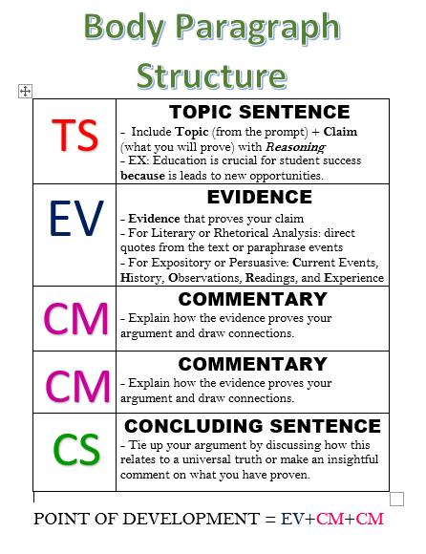
Developing a Body Paragraph
Analyzing the prompt:
If needed, turn the prompt into a question.
Prompt: Analyze how the setting of Anthem establishes ideas about collectivism.
How does the setting of Anthem establish ideas about collectivism?
Then, create a topic sentence by answering the question with one or more reasons, indicated by a subordinating conjunction or transition (“because” or “so that” or “in order to”).

[ASSERTION] + [REASONING] = [CLAIM]
The setting of Anthem establishes the idea that collectivism is harmful because…. [add one or more REASONS]. Do NOT use textual evidence (quotes or paraphrased details) as reasons.
- Incorrect: The setting of Anthem establishes the idea that collectivism is harmful because “their minds are shackled to the weakest and dullest ones among them” (Rand 100).

- Incorrect: The setting of Anthem establishes the idea that collectivism is harmful because Equality escapes this society and forms his own based on individuality.

- Correct: The setting of Anthem establishes the idea that collectivism is harmful because it prevents the progress of ideas and impedes individual success.

Developing the body paragraph:
[CLAIM] + [REASON] + [TEXT EVIDENCE] + [EXPLANATION] + [TEXT EVIDENCE] + [EXPLANATION]
Once you have established your topic sentence, you must develop out your body paragraph by providing sufficient textual evidence to support your central claim and commentary that explains how the evidence supports your reasons. Choose quotes or details that best work as EVIDENCE and use the analysis column to help you EXPLAIN how your evidence proves your topic sentence. Well-developed analysis will include at least TWO points of development. A point of development is a piece of TEXT EVIDENCE and two or more sentences of EXPLANATION.

Multiple Points of Development
A point of development is evidence and reasoning combined (EV and CM). As our paragraphs become more developed and complex, you may make several points in the same paragraph.
In Argument or Persuasive (example of student arguing that age does NOT determine maturity)
One Paragraph (with two p.o.d.) | Two Paragraphs (with one p.o.d. each)
TS – General (Maturity comes from hardship)  EV – Specific (financial stress)  CM  CM  EV – Specific (losing a loved one)  CM  CM  CS  *Note the way that in this paragraph they are both about hardship. Each p.o.d. must be on-topic for the topic sentence. | TS – General (Maturity comes from hardship)  EV – Specific (financial stress)  CM  CM  CS  TS – General (Maturity comes from responsibility)  EV – Specific (working a job)  CM  CM  CS

In Literary or Rhetorical Analysis (example of analysis of “Slam, Dunk, & Hook” with quotes)
One Paragraph (with two p.o.d.) | Two Paragraphs (with one p.o.d. each)
TS – General (mythological allusions add connotations of power and strength)  EV – Specific (“Mercury’s Insignia”)  CM  CM  EV – Specific (“roundhouse Labyrinth”)  CM  CM  CS  *Note the way that in this paragraph they are both the same type of device and they are both used to prove similar points. | TS – General (mythological allusions add connotations of power and strength)  EV – Specific (“Mercury’s Insignia”)  CM  CM  CS  TS – General (Christian allusions develop how basketball gives them spiritual renewal)  EV – Specific (“Swivels of bone & faith”)  CM  CM  CS

Note: If you are using several pieces of evidence in a single paragraph, ensure that you are still giving each its own unique commentary. The ratio of EV to CM should be close to 1:2, no matter how many facts or quotes appear in the paragraph.

Persuasive Writing on the STAAR Test
Organization and Essential Elements
Introduction
- Hook
- Claim
Body Paragraphs
- Support
- Concession/Refutation
Conclusion
- Call to action

Example Prompt
Read the following Quotation:
“A human can be healthy without killing animals for food. Therefore if he eats meat he participates in taking animal life merely for the sake of his appetite.” – Leo Tolstoy

Think about the statement: Some 9 billion animals are killed and used for food each year in the United States. The animal waste produced by factory farms causes water and air pollution.

Write an essay explaining your opinion on whether or not eating meat is humane.

Introduction: Hook
- Grabs the reader’s attention
- Establishes a connection between the reader and the writer
- May provide background information
Types of Hooks
Vivid Description Similes and Metaphors
Anecdote Fact or Statistic
Rhetorical Question Definition
Humor Quote
A warning about certain hooks:
Definition:
- Don’t define words in the prompt; Take a unique spin on the prompt. Instead of “humane” define “cruelty”
Rhetorical Question:
- Don’t reword the prompt; Provoke thought and don’t ask a “yes-or-no” question.
Anecdote:
- Don’t tell a story that is more than 2 lines long.
Fact/Statistics:
- Don’t make up facts; For STAAR, we know you don’t have the internet

Introduction: Claim
Claim: Statements about what is true or good or about what should be done or believed. To be a claim, not a mere assertion, the writer must provide reasons.
Ex: Eating animals is inhumane because it is unnecessary for human survival and animals are mistreated in order to provide food.

The claim is the “thesis” of argumentative or persuasive writing.
It should be the last sentence of the introduction.

Body Paragraph: Support
- Support your argument with evidence (facts) and reasoning (explanation)
- Evidence: Defense for claims. Strategically selected evidence strengthens the validity and reasoning of the argument, relates to an audience’s emotions and values, and increases an author’s credibility.
- CHORE: Current Events, History, Observations, Readings, Experience

Body Paragraph: Acknowledging other viewpoints
- STAAR will call this “addressing the complexity of the issue” in the rubric. Often essays without a C/R cannot earn more than a 3 out of 4.
- An essay without one of these may be seen as “limited” or “biased.”
Counterargument: the alternative or opposing positions are known as counterarguments.
Concession: When authors concede, they accept all or a portion of a competing position as correct, agree that the competing position or claim is correct under a different set of circumstances, OR acknowledge the limitations of their own argument.
Refutation/rebuttal: a contrasting perspective on an argument and its evidence or provide alternative evidence to propose that a competing position is invalid.
Concede means to yield or surrender

Example:
While some may argue that meat is part of a healthy diet, all of the essential amino acids that humans need can be found in plants, and diets that are heavy in red meat have been proven harmful.

Concession/ Refutation Warning
- You MUST refute any concessions or counterarguments that appear in your essay.
- Don’t spend more than a few lines arguing for your “opponent.”
- Pick a fact that opposes your argument, but don’t pick one that is so strong that you cannot effectively refute the fact. However, if there is a glaring hole in your argument, you must address it.

Conclusion: Call to Action
- Once you have concluded your essay, tell the reader what to do next.
- Voices a final plea to the audience (framed positively; “Do this” instead of “Don’t do that”)
- Uses active verbs directed at the reader
- References the claim
Ex:
Enjoy the benefits of a vegetarian diet that does not harm animals.

Example STAAR Essay
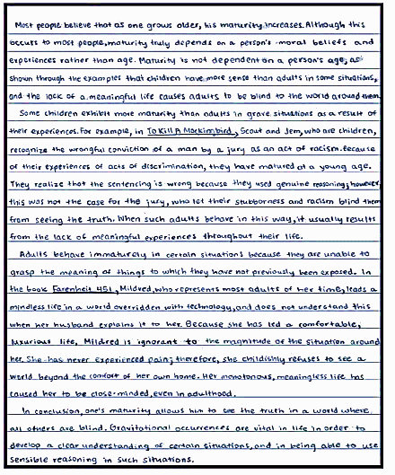

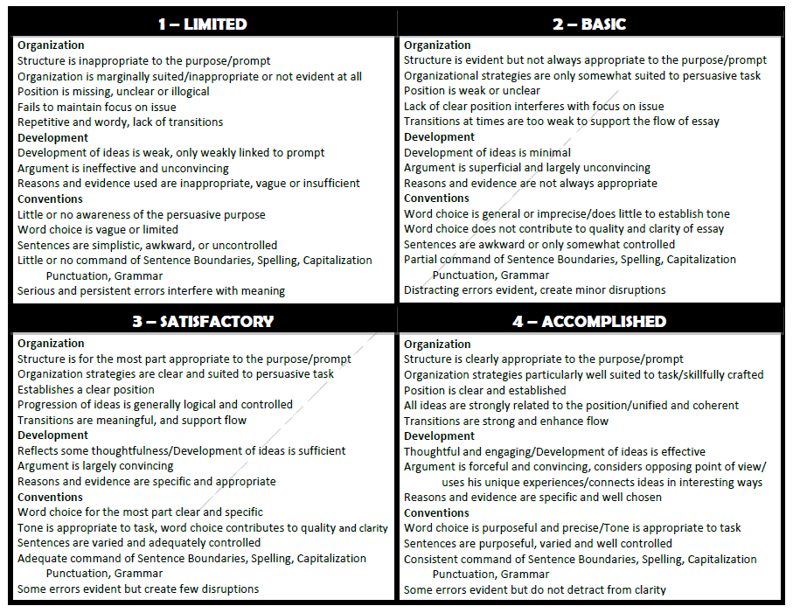

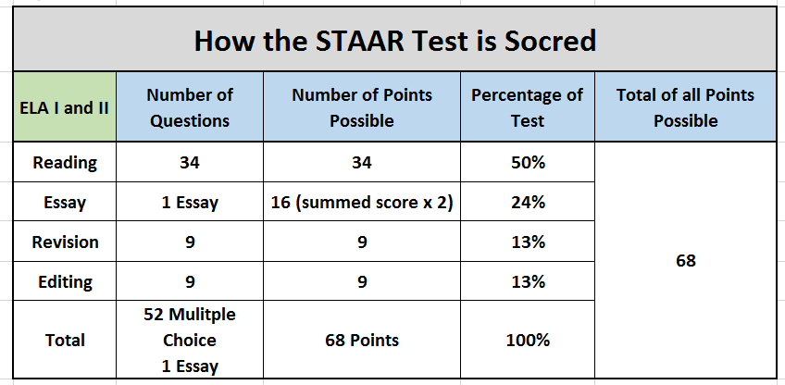
MLA FORMATING
MLA stands for the Modern Literature Association and essays for humanities (English, Social Studies, Art) are completed in this format in college and upper level high school. The reason that we use a standardized format is so that, if all papers look the same, they can be judged by content and not appearance. Here are the general outlines:

FONT:
- Times New Roman
- 12 pt
- The entire document should be double spaced

PARAGRAPHS:
- Double spaced
- No extra space between paragraphs or any information (title, name, teacher’s name, etc.)
- Indent one half of an inch (use the ruler) at the beginning of a new paragraph

HEADING
In order, on the left, include the following info
- Your Name
- Teacher’s Name
- Class Name (English II, Practical Writing)
- Date, written Day Month Year (11 January 2016)

TITLE
- Center aligned with no extra spaces between heading and essay

PAGE NUMBER
- LastName Page# should be on every page in the heading on the right side of the page.
- In Word, hit “Insert” then “Page Number” then select the page number at the top on the right side. In Header and Footer Menu, check “Different First Page” and leave the first page blank. Add your last name to the left of the number. Highlight all of the text and make sure that it is in the right font and size (Times New Roman 12pt.)

IN-TEXT CITATIONS
- Any time you use a quote or paraphrase the words of another person, you include certain information behind the sentence. If you include the author’s name in the sentence, this is not necessary. See https://owl.english.purdue.edu/owl/resource/747/02/ for more info. If the information is from a book, you must include the page number.
  - One great philosopher said, “Happiness depends upon ourselves” (Aristotle).
  - Aristotle said “Happiness depends upon ourselves.”

WORKS CITED
- This appears any time you use outside information to complete your essay. It is a new page after the essay is complete, NOT a separate document. Put “Works Cited” in the center top line and list your sites according to https://owl.english.purdue.edu/owl/resource/747/05/
MLA sample page

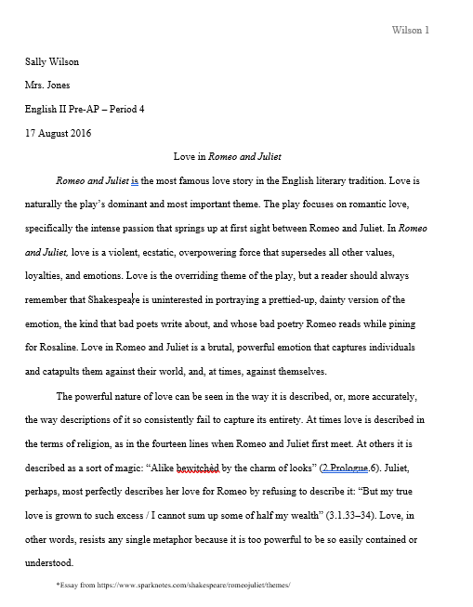

Synthesis Essay Notes
Overview
A synthesis essay is not a ________________ that consists of ____________________________, ________________________, or ________________________. Or Analysis that consists of ________________________________ or _____________________________.
A synthesis essay is an essay that consists of ________________________ and ___________________. A student is expected to _______________ a __________ product or __________ _____ __________.
The question requires you to ___________________ (pull apart/ dissect) a variety of ______________ into a _________________, ___________________, _______________. When you ________________ sources, you _____________ to them to _______________ your ________________ and ____________ them accurately. Your __________________ should be _______________; the source should be ________________ your __________________. _________________ merely ___________________ the ___________________.
The Six Step Process
- Read: When you ___________, you ____________ the source material quickly. Choose and read ____________ of these sources carefully. Think of these sources as your “guests” at a friendly dinner. While reading, take ______________, the best of which will work their way into your paper.
- Analyze: ________________ the ________________ each source makes. ✤ What ______________ is the source making about the issue? ✤ What _________________ (data/evidence/logic/appeals) does the source offer to bolster this claim? ✤ What ____________________ (explicit or implicit assumptions and beliefs) underlie this claim?
- Converse: ___________________ is the hardest (and most interesting) part! ✤ Imagine _________________ your best ideas to your three sources. ______________ ___________ the author of each source. ✤ Would the author ______________ or _________________ with you? Or would the author likely _____________________ your position? Why? How? ✤ Equally important: what are your ____________________, ___________________, and ______________________ opinions about each of your sources?

- Generalize: While keeping an open mind, ponder this question: “What _________________ (2 or 3) on this argument might I _______________, and why am I _______________ in this direction?” (what are my warrants?) ✤ Think about and use terms like “_______________,” “__________________” and “__________________.” ✤ Don’t _________________________or make ____________________ statements about your topic!
- Finesse: ________________ the _______________ point you want to make about your topic so that it can be expressed as a _____________. This thesis may be _____________ or _______________ -- that decision depends on the topic you are assigned. ✤ This _____________ should appear ____________ and __________________ in your essay; usually, it will constitute the last ________________ or two of the first paragraph. Finally, sketch out a ________________ for your response. This may be a personal experience or a hypothetical situation; regardless, it must lay the groundwork for the “conversation” that follows.
- Argue: Develop your _______________ in clear, flowing paragraphs. __________________ into your argument the positions of your ______________, _______________ them clearly. ✤ DO say things like, “Source A takes a position similar to mine;” or “Source C would likely oppose my position; I nevertheless assert I am correct because . . . .” DO begin with an __________________ you will later ________________ or ____________. This __________________ helps ensure that your paper will have a _________________ _________________, and not be simply a _________________ of _____________. End your paper with a short “so what?” paragraph, in which you briefly explore how your well-informed bright readers will be affected by the consequences of your developed contention! (look for a point made by one of your sources to use here)

Guideline for Sticky Notes
Requirements:
For each part of the novel you must write at least:
- 2 open response notes
- 1 theme brainstorm note
- 1 language notes
Open Response
You should have a variety of literal, inferential, and critical thoughts in these notes
This is a place to ask questions, voice opinions, record things you notice, summarize, and make connections

Theme Brainstorm
Explore themes that you think the author is thinking of while writing the novel. Connect to large ideas such as hope, humanity, identity, etc.

Language Notes
Identify sections that are strong and evocative and analyze how the language contributes to that meaning
Analyze a section for syntax, connotation and denotation, or make note of a symbol that you see in the text. How do the words that the author chooses contribute to the flow and the impact of the language?

